**Basic Programming Assignment Meeting 3**



**From:**

AL AZHAR RIZQI RIFA’I FIRDAUS

**Class:**

1 I

**Absence:**

01

**Major:**

Information Technology

**Study Program:**

Informatic Engineering

**Question !**

1. Two years ago, Harry was 6 times the age of Laras. Eighteen years later Harry will be twice as old as Laras. Create an algorithm and flowchart to determine the age of Harry and Laras!

2. Calculate the final score of students from the average score of assignment, quiz, midterm exam, and final exam! (Assumption: there is only 1 assignment score and 1 quiz score)

**Answer**

1. Algorithm

* Input : Harry was 6 times the age of Laras, Harry = x, Laras = y
* Process :
  + SPLDV = x–6y=-10 (i)
    - X–2y=18 (ii)

X–6=-10

X=-10+6y (iii)

* + Subtitution (iii) and (ii) to get y value.

X–2y=18

-10+6y-2y=18

-10+4y=18

4y=18+10

4y=28

Y=7 (iv)

* + Subtitution (iv) to (iii)

X=-10+6y

X=-10+6(7)

X=-10+42

X=32

* So the age of Harry 32, and Laras 7
* Output : Age of Harry and Laras

Flowchart

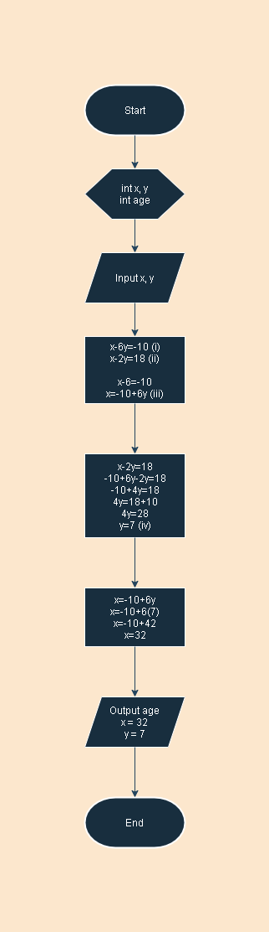

1. Flowchart

